**Project Design Phase-II**

**Data Flow Diagram & User Stories**

|  |  |
| --- | --- |
| Date | 03 October 2022 |
| Team ID | PNT2022TMID32919 |
| Project Name | Project - SmartFarmer - IoT Enabled Smart Farming Application |
| Maximum Marks | 4 Marks |

**Data Flow Diagrams:**

A Data Flow Diagram (DFD) is a traditional visual representation of the information flows within a system. A neat and clear DFD can depict the right amount of the system requirement graphically. It shows how data enters and leaves the system, what changes the information, and where data is stored.

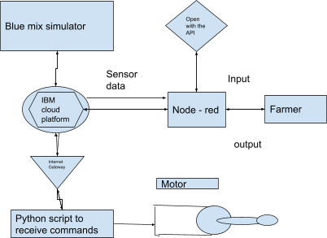

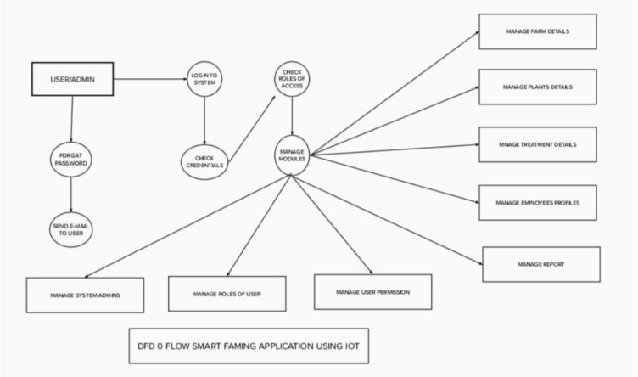

* Different sensors are used to measure the various soil factors, such as temperature, moisture content, and humidity, and the results are then saved in the IBM cloud.
* The Ardiuno UNO is utilised as a processing component to process the sensor data as well as weather API data.
* NODE-RED is a programming language that is used to create the hardware, software, and APIs. The communication adheres to the MQTT protocol.
* A mobile application created with MIT App Inventor is used to deliver all the collected data to the Jser. Through an app, the user might decide. Depending on the sensor results, decide whether to irrigate the crop or not. They can remotely control the motor switch by utilising the app.

**User Stories**

Use the below template to list all the user stories for the product.

